The Wylie Inn — Weekly Revenue Report
September 16, 2026
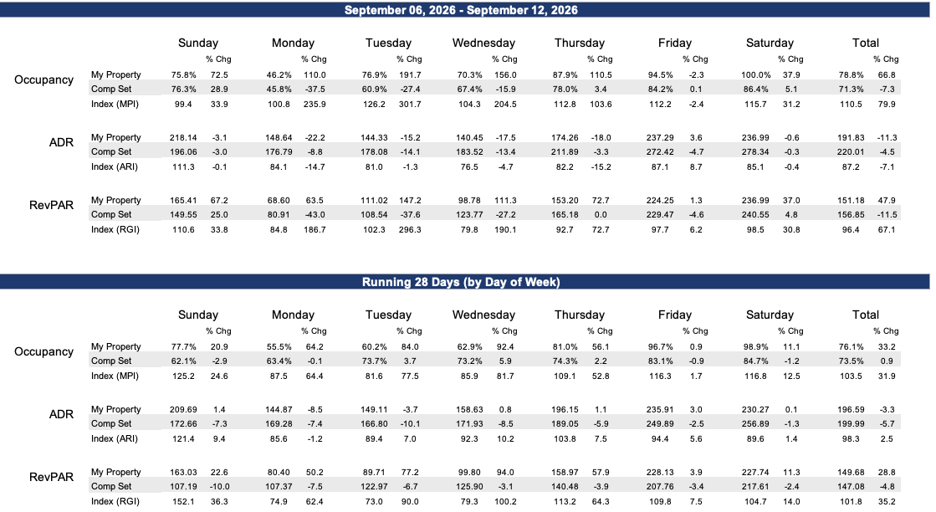

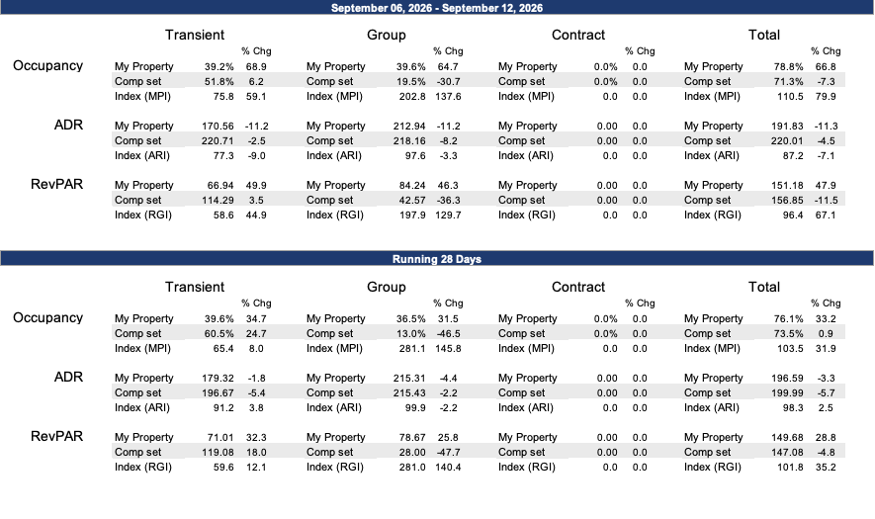

Rate Shop vs. Comp Set

Day | Date | Wylie Avail | The Wylie Inn | Salem Waterfront Hotel & Suites | Hawthorne Hotel | Residence Inn Boston North Shore/Danvers | Sonesta Select Boston Danvers | Homewood Suites by Hilton Boston - Peabody | Hampton Inn Salem, Ma
Wed | 09/16 | 0 | Sold out | Sold out | Sold out | Sold out | 194 | Sold out | Sold out
Thu | 09/17 | 7 | 320 | No flex | 334 | 189 | 169 | 189 | Sold out
Fri | 09/18 | 3 | Sold out | No flex | Sold out | 329 | 299 | Sold out | Sold out
Sat | 09/19 | 0 | Sold out | Sold out | Sold out | Sold out | 449 | Sold out | Sold out
Sun | 09/20 | 36 | 189 | Sold out | Sold out | 170 | 169 | 289 | 479
Mon | 09/21 | 15 | 198 | No flex | Sold out | 161 | 169 | 179 | 419
Tue | 09/22 | 15 | 216 | No flex | Sold out | 188 | 169 | 261 | 429
Wed | 09/23 | 13 | Sold out | Sold out | Sold out | 188 | 169 | 252 | Sold out
Thu | 09/24 | 1 | Sold out | Sold out | Sold out | 170 | 169 | 321 | Sold out
Fri | 09/25 | 0 | 261 | No flex | Sold out | Sold out | Sold out | Sold out | Sold out
Sat | 09/26 | 0 | Sold out | Sold out | Sold out | Sold out | Sold out | Sold out | Sold out
Sun | 09/27 | 16 | 234 | No flex | Sold out | 152 | 244 | 252 | 519
Mon | 09/28 | 12 | 198 | Sold out | Sold out | 189 | 204 | 179 | 519
Tue | 09/29 | 1 | 216 | No flex | Sold out | 189 | 199 | 229 | LOS2
Wed | 09/30 | 10 | 261 | No flex | Sold out | 233 | 199 | 339 | 699
Thu | 10/01 | 34 | 351 | Sold out | Sold out | 359 | 549 | Sold out | 799
Fri | 10/02 | 2 | Sold out | Sold out | Sold out | 509 | 719 | Sold out | Sold out
Sat | 10/03 | 12 | 675 | Sold out | Sold out | Sold out | LOS2 | Sold out | Sold out
Sun | 10/04 | 11 | 360 | No flex | Sold out | 229 | 269 | 369 | Sold out
Mon | 10/05 | 34 | 387 | No flex | Sold out | 309 | 269 | 369 | 699
Tue | 10/06 | 0 | Sold out | Sold out | Sold out | 278 | 279 | 389 | 789
Wed | 10/07 | 6 | Sold out | No flex | Sold out | 309 | 269 | 369 | 829
Thu | 10/08 | 53 | 369 | No flex | Sold out | 296 | 269 | 449 | 849
Fri | 10/09 | 16 | 225 | Sold out | Sold out | 509 | 719 | Sold out | Sold out
Sat | 10/10 | 0 | Sold out | Sold out | Sold out | Sold out | Sold out | LOS3 | Sold out
Sun | 10/11 | 43 | 477 | No flex | Sold out | 329 | 259 | LOS2 | Sold out
Mon | 10/12 | 0 | Sold out | No flex | 569 | 278 | 249 | 369 | Sold out
Tue | 10/13 | 0 | Sold out | No flex | Sold out | 278 | 249 | 388 | 629
Wed | 10/14 | 0 | Sold out | No flex | Sold out | 309 | 249 | 369 | 789
Thu | 10/15 | 18 | 387 | Sold out | Sold out | 296 | 249 | 449 | Sold out
Fri | 10/16 | 8 | Sold out | Sold out | Sold out | Sold out | 719 | Sold out | Sold out
Sat | 10/17 | 36 | Sold out | Sold out | Sold out | Sold out | LOS2 | Sold out | Sold out
Sun | 10/18 | 43 | 288 | No flex | Sold out | 260 | 549 | 369 | Sold out
Mon | 10/19 | 30 | 288 | No flex | Sold out | 260 | 289 | 369 | 789
Tue | 10/20 | 0 | 351 | No flex | Sold out | 260 | 289 | 344 | 739
Wed | 10/21 | 11 | 351 | No flex | Sold out | 309 | 289 | 304 | 699
Thu | 10/22 | -1 | Sold out | Sold out | 569 | 278 | 289 | 449 | 849
Fri | 10/23 | 0 | Sold out | Sold out | Sold out | 509 | 719 | Sold out | Sold out
Sat | 10/24 | 28 | 675 | No flex | Sold out | 509 | LOS2 | Sold out | Sold out
Sun | 10/25 | 50 | 360 | No flex | Sold out | 206 | 271 | 369 | 699
Mon | 10/26 | 52 | 360 | No flex | 569 | 206 | 274 | 369 | 699
Tue | 10/27 | 49 | 360 | No flex | 579 | 206 | 250 | 352 | 699
Wed | 10/28 | 48 | 360 | No flex | Sold out | 206 | 250 | 369 | 739
Thu | 10/29 | 30 | 360 | No flex | 569 | 329 | 250 | Sold out | LOS2
Fri | 10/30 | 29 | 630 | No flex | Sold out | Sold out | 719 | Sold out | 1799
Sat | 10/31 | 18 | 648 | Sold out | Sold out | Sold out | LOS2 | Sold out | Sold out
Tue | 12/01 | 81 | 144 | No flex | 179 | 152 | 119 | 139 | 164
Wed | 12/02 | 81 | 144 | No flex | 179 | 152 | 119 | 139 | 164
Thu | 12/03 | 81 | 144 | Sold out | 184 | 152 | 119 | 139 | 164
Fri | 12/04 | -1 | Sold out | No flex | Sold out | 170 | 129 | 149 | 199
Sat | 12/05 | 16 | 189 | No flex | Sold out | 170 | 129 | 149 | LOS2
Sun | 12/06 | 78 | 126 | No flex | 184 | 152 | 119 | 140 | 154
Mon | 12/07 | 73 | 135 | No flex | 179 | 152 | 119 | 139 | 164
Tue | 12/08 | 73 | 144 | No flex | 179 | 152 | 119 | 139 | 164
Wed | 12/09 | 73 | 144 | No flex | 179 | 152 | 119 | 139 | 164
Thu | 12/10 | 72 | 144 | No flex | 184 | 152 | 119 | 139 | 164
Fri | 12/11 | 13 | 162 | No flex | 241 | 170 | 129 | 149 | 189
Sat | 12/12 | 48 | 189 | No flex | Sold out | 170 | 129 | 149 | 189
Sun | 12/13 | 79 | 126 | No flex | 184 | 152 | 119 | 139 | 154
Mon | 12/14 | 80 | 126 | No flex | 179 | 152 | 119 | 139 | 164
Tue | 12/15 | 78 | 126 | No flex | 179 | 152 | 119 | 139 | 161
Wylie sold out while comp set still has availability: 09/16, 09/19, 10/06, 10/12, 10/13, 10/14, 10/20, 10/22, 10/23, 12/04
Priced below entire comp set: 10/01, 10/09, 10/30

Expedia

Last Year
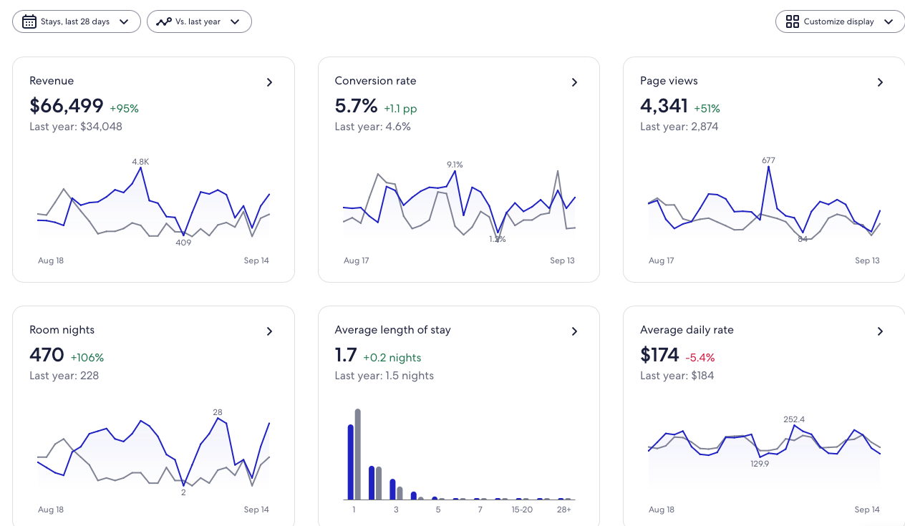

Competition
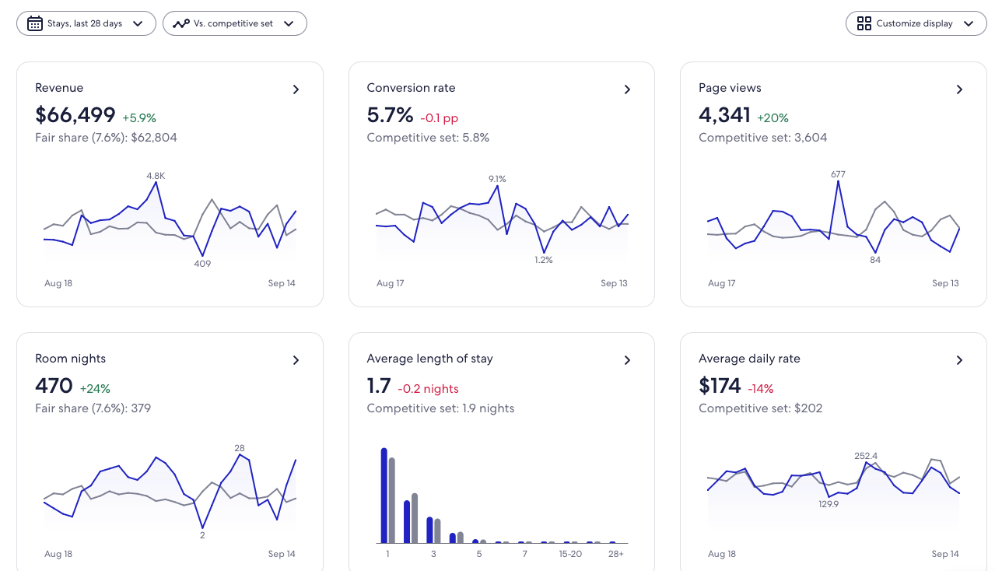

Promotions
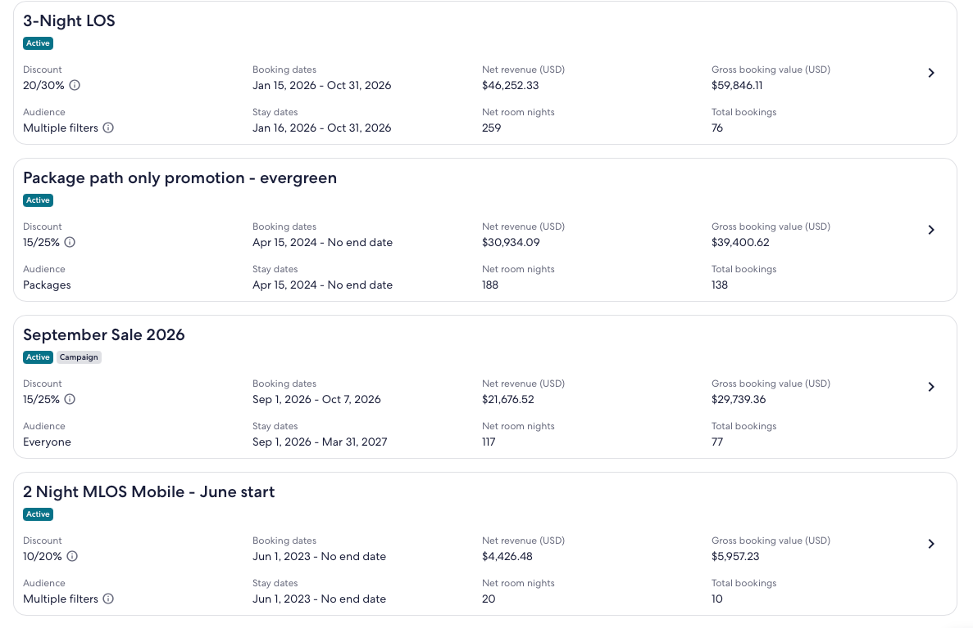

TravelAds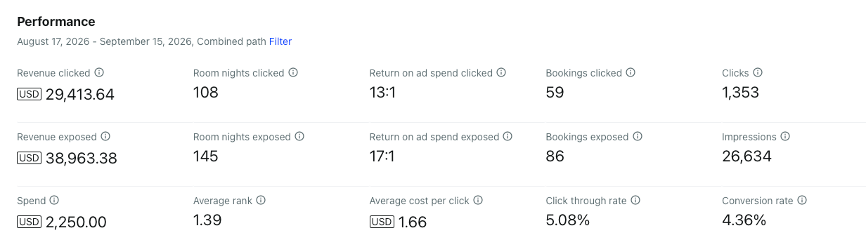
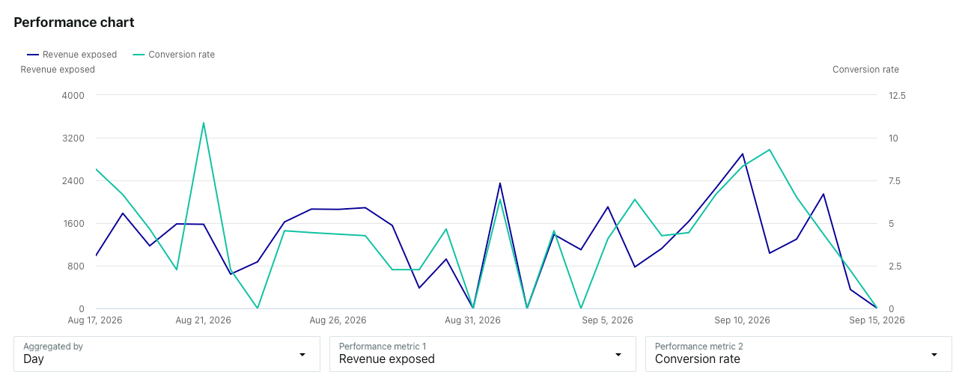

Booking

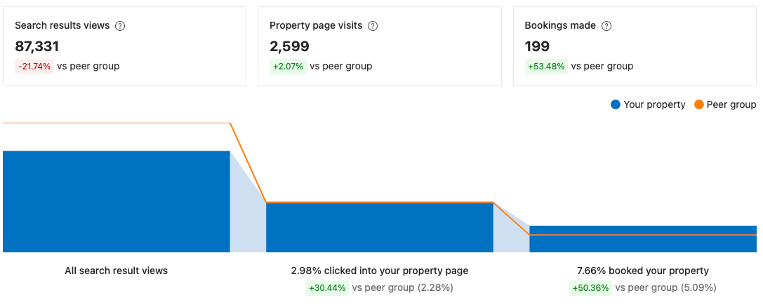

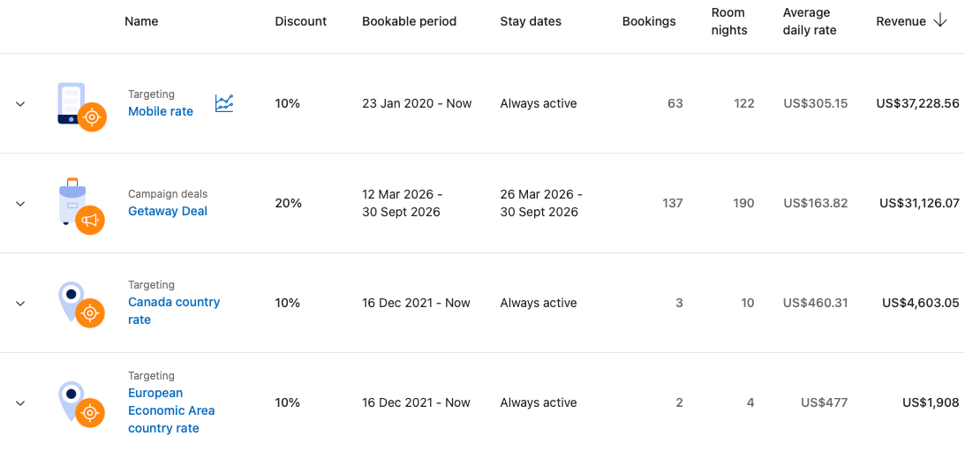



- Rework Gallery page to be more modern and styled - https://wyliecenter.com/gallery/
- Update Gallery on the Amenities page - https://wyliecenter.com/amenities
- Update Gallery on Docs page - https://wyliecenter.com/docs-bar/
- Update and improve the design of the Meetings and Weddings Testimonials slider - Both Wylie & Tupper
- Write copy and buildout the Trainings page - https://wyliecenter.com/packages/training/
- Write copy and buildout the Staff page - https://wyliecenter.com/packages/onsite-staff/
- Review and revise FAQ page - https://wyliecenter.com/faq/
- Incorporate FAQs throughout the site on most pages
- Tupper: Update the out dated Testimonials - https://tuppermanor.com/weddings/testimonials/
- Tupper: Add Package/Menu information - https://tuppermanor.com/package-menu/

